

American International University- Bangladesh

CSC 4261: Advanced Programming in Web Technology

CO1 Evaluation

Project Report

SPRING 23-24

Project Title: E-Commerce site

Project Domain: ---------

Group Number: 10

Section: C

|  |  |
| --- | --- |
| Student Name | Student Id |
| TANJIL HASAN SAKIB | 20-43633-2 |

**Introduction:**

The goal of this project is to create an e-commerce site that is easy to use, therefore revolutionizing online shopping. Our mission is to elevate and streamline online shopping, making it convenient and pleasurable for consumers all over our country. We achieve this by focusing on improving the customer experience, expediting transactions, and offering a large variety of products.

**Problem Analysis:**

Current e-commerce platforms often suffer from complex user interfaces, inefficient navigation, and limited product variety, leading to a suboptimal shopping experience. The need for a seamless and diverse online shopping solution is crucial to addressing customer frustrations and enhancing overall satisfaction.

Significance: Solving these issues is essential for fostering user engagement, increasing sales, and establishing customer loyalty. A user-friendly, feature-rich e-commerce site can significantly improve the overall online shopping experience, making it more enjoyable and efficient for consumers.

**Existing Solutions:**

Amazon (www.amazon.com): Description: One of the largest and most diverse e-commerce platforms globally, Amazon offers a vast array of products. However, its interface can be overwhelming for some users, and the sheer volume of options may lead to decision fatigue.

Etsy (www.etsy.com): Description: Specialising in handmade and unique products, Etsy provides a niche market for creators. However, its search and filtering options could be more intuitive, affecting the ease of product discovery.

Walmart (www.walmart.com): Description: Walmart's e-commerce platform offers a wide range of products at competitive prices. However, the user experience may be less personalised, and the site's design could be more modern and user-friendly.

The proposed e-commerce project aims to amalgamate the best features of existing platforms while addressing their shortcomings, creating a platform that combines diversity, user-friendliness, and efficiency for an optimal shopping experience.

Feature Analysis:

1. User Category:

There are 1-types of Users here.

* Admin

Feature List:

In this project the “Admin” has the following features:

* Sign up
* Sign in
* Update admin
* Delete all admin
* Logout
* Show all admin
* Search admin by id
* Find admin by mail
* Update admin by id
* Delete admin by id
* Insert admin
* Insert manager
* Get all manager with admin
* Find managers by admin id
* get image by image name
* get all manager
* get image by admin id

Design:

Draw a Use Case diagram of your project here.

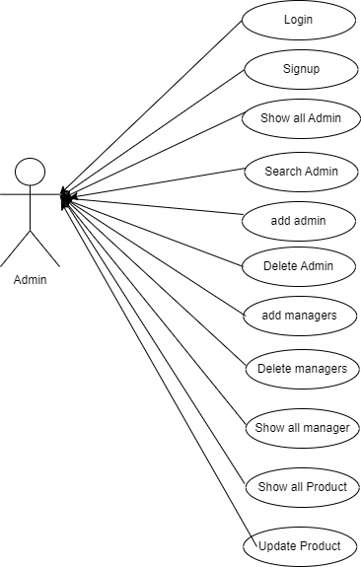

Draw a ER diagram of your project here.

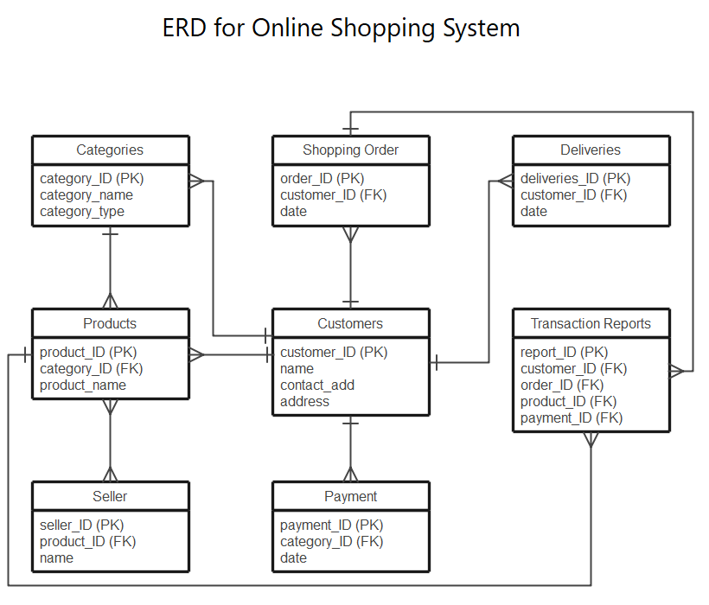

Tools Used:

To develop this project, we have used the following:

* Visual code
* Postman
* Node.js
* Postgresql

**Impact of this Project:**

This E-Commerce project is pivotal in modern society, offering a streamlined, eco-friendly alternative to traditional retail. With its simple, environmentally responsible approach to traditional retail, this e-commerce enterprise is essential to current civilization. It lessens the carbon footprint related to brick-and-mortar establishments by encouraging efficient online shopping. Customers save time and money with a diversified, easy-to-use platform. The project fosters sustainable consumption habits and complies with the changing demands of a digitally connected society, all while aligning with modern principles.

**Limitations and Possible Future Improvements:**

Limitations may include potential scalability challenges and initial user adaptation. Enhancing AI-driven personalization for customized shopping experiences, improving site responsiveness, and incorporating cutting-edge technology like augmented reality for virtual product trials could be the main areas of future development. Maintaining relevance and staying ahead of market trends will require regular user input assessments and continuous technology updates.

|  |  |  |  |
| --- | --- | --- | --- |
| CO1 Evaluation: Project Report Evaluation | | | |
| Problem  Analysis  (5) | Use Case  Diagram  (5) | ER  Diagram  (5) | Total (15) |
|  |  |  |  |
|  | | | |